  

* Start by updating the apt packages index.

**$ sudo apt update**

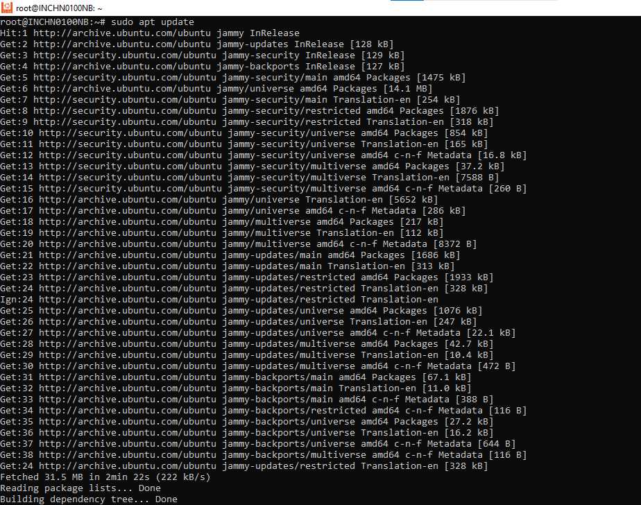

* Install the Samba package with the following command.

**$ sudo apt install samba**

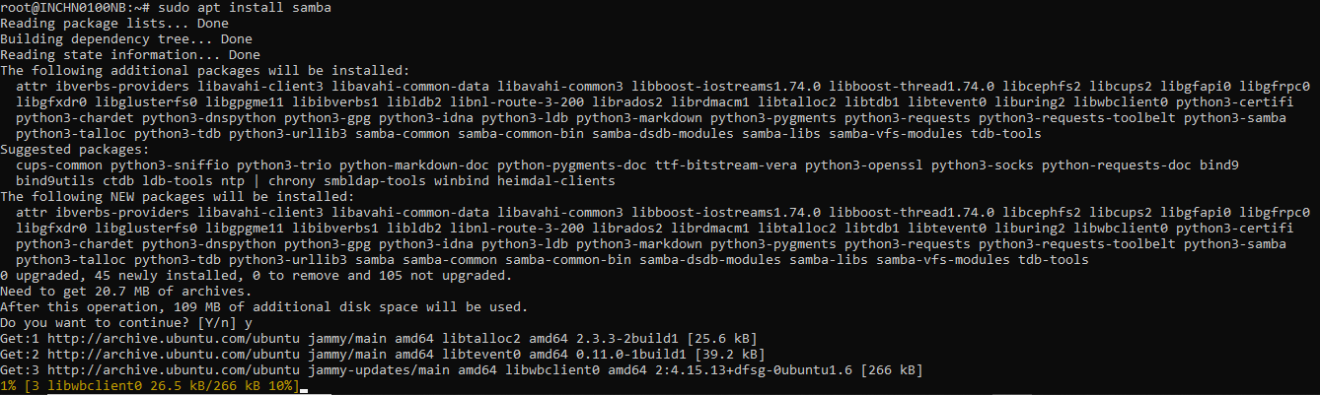

* Once the installation is completed, the Samba service will start automatically. To check whether the Samba server is running, type

**$ sudo systemctl status smbd**

The output should look something like below indicating that Samba service is active and running:

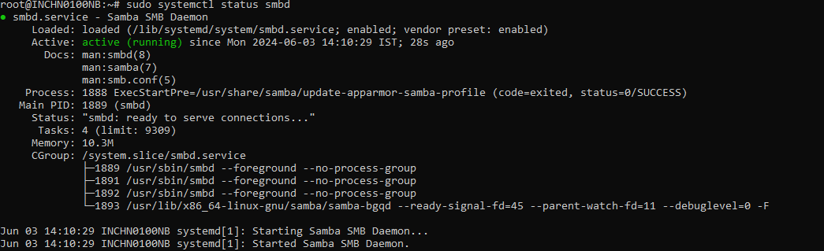

At this point, Samba has been installed and ready to be configured.

* Configure firewall

**$ sudo ufw allow 'Samba'**

* Take copy of smb.conf by using following command.

**$ sudo cp /etc/samba/smb.conf{,.backup}**

## **Creating Samba Users and Directory Structure**

* To create the /samba directory type:

**$ sudo mkdir /samba**

* Set the group ownership to sambashare. This group is created during the Samba installation, later we will add all Samba users to this group.

**$ sudo chgrp sambashare /samba**

* Create the user’s home directory and set the directory ownership to user Smbuser and group sambashare.

**$ sudo mkdir /samba/ScanTest**

* To create a new user named Smbuser use the following command.

**$ sudo useradd -M -d /samba/ScanTest -s /usr/sbin/nologin -G sambashare Smbuser**

* Set the group ownership to sambashare. This group is created during the Samba installation, later we will add all Samba users to this group.

**$ sudo chgrp sambashare /samba/ScanTest**

* Set the directory ownership to user Smbuser and group sambashare

**$ sudo chown Smbuser:sambashare /samba/ScanTest**

* Give permissions to shared folder.

**$ sudo chmod 2770 /samba/ScanTest**

* Add the Smbuser user account to the Samba database by setting the user password.

**$ sudo smbpasswd -a Smbuser**

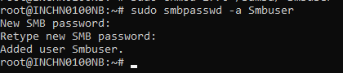

* Enable the user.

**$ sudo smbpasswd -e Smbuser**



* Edit the smb.conf file using below command

**$ sudo nano /etc/samba/smb.conf**

Align file commands with the image. Add any missing global commands.

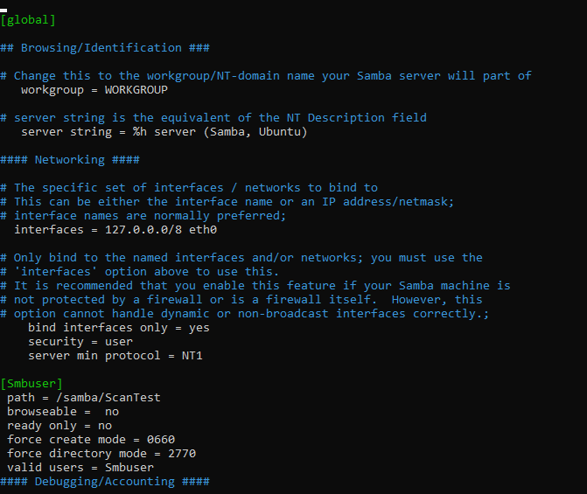

* Once done, restart the Samba services with

**$ sudo systemctl restart smbd**

**$ sudo systemctl restart nmbd**

* Then enable these commands to start automatically

**$ sudo systemctl enable nmbd**

**$ sudo systemctl enable smbd**

For encryption in samba config change the following commands in config smb.conf file

* Edit the smb.conf file using below command

**$ sudo nano /etc/samba/smb.conf**

Align file commands with the image. Add any missing global commands.

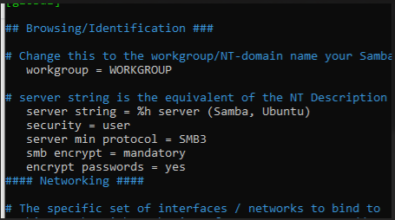

* Once done, restart the Samba services with

**$ sudo systemctl restart smbd**

**$ sudo systemctl restart nmbd**

SMB (**Server Message Block**) is a network file sharing protocol